2200032991
Puru Sai Koushik

Financial Forecasting:
Scenario:
You are developing a financial forecasting tool that predicts future values based on past data.

Output:
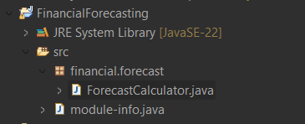

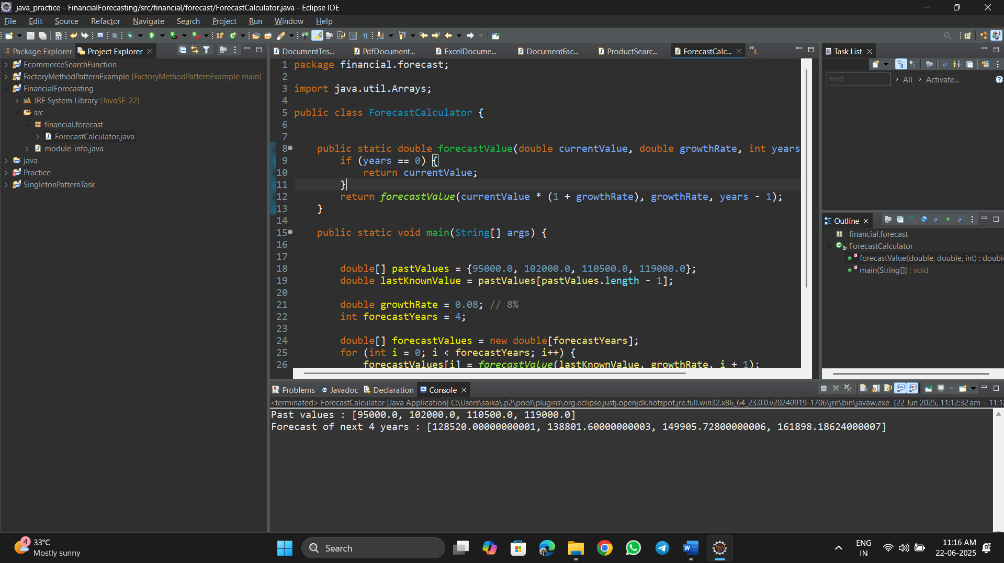

ForecastCalculator.java:
package financial.forecast;

import java.util.Arrays;

public class ForecastCalculator {

public static double forecastValue(double currentValue, double growthRate, int years) {
if (years == 0) {
return currentValue;
}
return forecastValue(currentValue * (1 + growthRate), growthRate, years - 1);
}

public static void main(String[] args) {

double[] pastValues = {95000.0, 102000.0, 110500.0, 119000.0};
double lastKnownValue = pastValues[pastValues.length - 1];

double growthRate = 0.08; // 8%
int forecastYears = 4;

double[] forecastValues = new double[forecastYears];
for (int i = 0; i < forecastYears; i++) {
forecastValues[i] = forecastValue(lastKnownValue, growthRate, i + 1);
}

System.out.println("Past values : " + Arrays.toString(pastValues));
System.out.println("Forecast of next " + forecastYears + " years : " + Arrays.toString(forecastValues));
}
}

